

**UTTARA UNIVERSITY**

**PROJECT PROPOSAL ON**

**SMART OFFICE NETWORKING SYSTEM**

**GROUP MEMBERS**

**NUSRAT JAHAN BITHI 2192081026 48ADAY**

**TONIMA AKTER 2191081017 47ADAY**

**ISRAT JAHAN SATHI 2192081027 48ADAY**

**AMIT HASAN 2192081017 48ADAY**

**Supervisor:** **Ratul sikder**

**Coordinator:** MD.Torikul Rahman

Summer 2022

BSc. In Computer Science and Engineering, Department of Computer Science and Engineering, Uttara University, Uttara, Dhaka, Bangladesh.

*Project on sons , summer 22*

**ABSTRACT**

*This project is aimed at developing a desktop and mobile based named smart office networking system. Technology plays a critical role in all daily activities of the present day. Think of a smart office network setup as having a foundation of switches and routers. A switch is any piece of equipment that allows networked devices to communicate and share information. On an Ethernet network, you’re connecting desktop PCs, printers, servers, network attached storage (NAS), voice over IP (VoIP), surveillance systems—any device with an Ethernet cable port. Switches tie together these devices into a network.*

a*ll over the world, security has been a major concern in every office. Automated security systems are a useful addition to todays office where safety is an important issue. Vision-based security systems have the advantage of being easy to set up, inexpensive and nonobtrusive. Here, a security system has been developed that uses sensors to detect any security violation and sends out the alert signal by high intensity Buzzer. In this paper it has been ensured four level security systems. One of these needs is to create a smart office that controls operation and turns off electronic devices via a smartphone. This implementation can be implemented effectively using package tracking software that includes IoT functions to control and simulate a smart office.* *So, maximum security will be maintained in office. This security can be applied not only office but also the place where important document, file are preserved also the bank vault using home*

***Keywords :*** *IOT technology, Cisco Packet Tracer, IoT server, IoT moniotor,router,pcs, switch, Fan, light, Window, Garage, Door, Battery, Siren, Solar panel, Appliance, Portable music player, Motion Detector, Street lamp, Old car, Fire monitor, RFID card, RFID reader, Trip sensor, Fire sprinkler,tv etc*

*Nusrat jahan bithi, 2192081026 48A Day, Tonima akter, 2191081017 47A,*

*Israt jahan sathi, 2192081027 48A Day,Amit hasan, 2192081017 48A Day*

*Project on SSS, summer 22*

**TABLE OF CONTENT**

**1. INTRODUCTION**.......................................................................................................... 1

1.1 Introduction to Smart office networking System .......................................... 2

1.2 The importance of computer networks........................................................................ 3

1.3 Benefits of the computer network........................................................................ 4

1.4 Objective of the Project…………………………………………………………………… 5

**2 . Configure an IP Address on a Cisco Router** ....................................... 6

2.1. Switch ip configuration .............................................................................. ……. 9

2.3.  IP telephony basic configuration ................................................................... 13

### 3 Office Automation Using IoT ...................................................... 14

3. Project features............................................................................... 14

3.1 Mcu…………………………………………………………………………………… 14

3.1.2 RFID Based DoorLock........................................................................... 1 4

3.1.3 Smart Window, based on light...................................................................... 15

3.1.4 Solar Power battery charging ........................................................................... . 15

3.1.5 .Auto fan & coffee ......................................................................................... 15

3.1.6. Music player: ......................................................................................... 15

3.1.7 .Smart street lamp....................................................................................... 15

3.1.8. Temperature monitors............................................................................... 16

3.1.9. webcam..................................................................................... 16

. 3.19 Fire alarm & smoke alarm..................................................................... 16

3.1.9. Ac……………………………………………………………………………………. 17

### 

### 4 smart office environment summary ……………………………………………….. 18

5 REFERENCES ........................................................................................................... 19

6 SHORT BIOGRAPHY….……………………………………...…………................................. 20

*Nusrat jahan bithi, 2192081026 48A Day, Tonima akter, 2191081017 47A,*

*Israt jahan sathi, 2192081027 48A Day,Amit hasan, 2192081017 48A Day*

*Project on sons, summer 22*

***Smart office networking system***

***Nusrat Jahan Bithi, Tonima Akter, Israt Jahan Sathi andAmit hasan***

***2192081026 48ADAY***

***2191081017 47ADAY***

***2192081027 48ADAY***

***2192081017 48ADAY***

**1.Introduction**

*The project smart office networking System is a complete desktop and mobile based cisco pakect blynk apps. Smart offices use technology to increase productivity and collaboration. Smart office automation and technology also improves the working environment through energy efficiency, enhanced security, and streamlining processes. By utilizing connected technology and data analytics to ensure the workplace is equipped for the specific needs of each unique workforce, smart offices are able to quickly adapt and evolve with their organizations. An office space equipped with IoT devices, and thus connected to the internet, is often referred to as a “smart office”. It represents an intelligent ecosystem that relies on a number of connected devices that, in general, monitor, control, and manage various operations and working conditions. Security cameras, smart locks, Siren, Solar panel, Appliance, Portable music player, Motion Detector, Street lamp, Old car, Fire monitor, RFID card, RFID reader, Trip sensor, Fire sprinkler,tv and various sensors are the most popular Applications for IoT in office spaces.*

*In addition, you can eliminate the outdated pass system, replacing physical badges with digital ones. Thus, all you need is your smartphone with the installed app to clock in or out. The same applies to*[*visitor management*](http://www.quickplusapps.org/)*and*[*access control*](https://www.getkisi.com/)*.*

***1. Smart Office Technology***

***2. Smart Security and Access Control Systems***

***3. Meeting Room & waiting room***

***4. Collaboration Tools***

***5. Smart Office Accessories***

***6. Office Supply Management***

***7. Planning Your Smart Office Checklist***

***8. Smart Technology in the Post-Coronavirus Pandemic Office***

***9. Advanced Security Management for our Smart Office***

*Nusrat jahan bithi, 2192081026 48A Day, Tonima akter, 2191081017 47A,*

*Israt jahan sathi, 2192081027 48A Day,Amit hasan, 2192081017 48A Day*

***Page 1 of 2***

*Project on sons, summer 22*

1.2 The importance of computer networks

*In the world of Information Technology (IT) information is building block for effective communication. Communication is medium that helps us to drive our day to day professional and personal operations. Where computer networking acts as base of everything as the best and most important IT solutions. Below is list of points that we do with the help of computer networks, or things that we get benefited with the help of computer networks or it has become possible or effective due to computer network. Let us know all points and after that, we can understand importance of computer networking.*

* *Provides best way of business communication.*
* *Streamline communication.*
* *Cost-effective resource sharing.*
* *Improving storage efficiency and volume.*
* *Cut costs on software.*
* *Cut costs on hardware.*
* *Utilizes Centralized Database.*
* *Increase in efficiency.*
* *Optimize convenience and flexibility.*
* *Allows File sharing.*
* *sharing of peripherals and internet access.*
* *Network gaming.*
* [*Voice over IP (VoIP)*](https://www.geeksforgeeks.org/voice-over-internet-protocol-voip/)*.*
* *Media Center Server.*
* *Centralize network administration, meaning less IT support.*
* *Flexibility.*
* *Allowing information sharing.*
* *Supporting distributed processing.*
* *User communication.*
* *Overcoming geographic separation.*

*In general, we can see “****Communication” and “Sharing”,****that is all networking is about in simple terms. It enables everything that we do today. In the current scenario, the business would not work without computer networking and our personal and social life will also feel like it has been stopped.*

*Page* ***2*** *of* ***20***

*Project on sons, summer 22*

1.3 Benefits of the computer network

*⮚ networking is moving more towards wireless so that devices may use the feature of mobility like we use laptops, smartphones, and smart TVs and these devices may get placed anywhere and still can be connected to the network.*

*The important Advantages/Benefits of Computer Network and uses are the following. The important benefits and uses of networking are following.*

*• File sharing*

*It provides access to digital media, such as a computer, programs, electronic book odocuments. Common methods of storage and transmission include manual shareing utilizing removable media, centralized servers on computer networks.*

*• Application sharing*

*It enables the two or more users to access a shared application or software over the network with the help of client/server application*

*• Hardware sharing*

*In hardware, sharing user can access the hardware devices like Printer, Hard disk,Ram etc. with the help centralized computer or device.*

*• User Communication:*

*Networks allow users to communicate using e-mail, newsgroups, and videoconferencing etc.• Network Gaming*

*A user can get the benefit of gaming over the network as it also provides networkgaming where two or more users can play a game from a different location.*

*Page* ***3*** *of* ***20***

⮚**Security of Data:** *With the increase in technology day by day, the number of cases of cybercrimes has been increasing also. So, it is very important to secure your network*

*and [confidentialinformation](https://www.contractstandards.com/public/clauses/confidential-information" \l ":~:text=%22Confidential%20Information%22%20means%20all%20material,means%20of%20communication%20or%20observation.) from the outside world or hackers.  
To avoid these situations, one needs to network security practices to secure the network.*

*Some devices that we use in the networks are the following devices:*

1. [*Switch*](https://snabaynetworking.com/what-is-a-network-switch/)***:****Most used networking devices nowadays used for local area network connection.*
2. [*Router*](https://snabaynetworking.com/what-is-router-in-networking/)***:****It is used to send the user data from one network to another network.*
3. ***Firewall:****It is a security networking device that monitors the incoming and outgoing traffic of the network.*
4. ***Computers:****These are the devices that are used by the end-users to complete their daily task. These computers or laptops may come with different operating systems like Windows, Linux, and many others.*
5. ***NAS or SAN:****These are the*[*centralized storages*](https://iweb.com/blog/the-benefits-of-centralized-storage-for-servers#:~:text=Centralized%20storage%20is%20the%20storage,as%20Direct%2DAttached%20Storage).)*that are attached to the network and available for the users having the network access.*
6. ***Network Printers:****These are the printers wherein IP address is assigned and these printers can be accessed by the users over the network for the printout.*

.

*Nusrat jahan bithi, 2192081026 48A Day, Tonima akter, 2191081017 47A,*

*Israt jahan sathi, 2192081027 48A Day,Amit hasan, 2192081017 48A Day*

*Page* ***4*** *of* ***2***

*Project on sons, summer 22*

1.4 Objective of the Project

*Technology plays a critical role in all daily activities of the present day. One of these needs is to create a smart home that controls operation and turns off electronic devices via a smartphone. This implementation can be implemented effectively using package tracking software that includes IoT functions to control and simulate a smart home. IoT technology can be applied to many real life issues, such as: homework, treatment, campus, office, etc. In this paper, the focus is on a safe home system that includes devices such as: air conditioning, alarm, lighting, and doors. Garage that is some of the day to day issues. The aim of this research is to come up with a simulation of smart devices that can be controlled by the end-user smart device remotely and then show the concept called smart home. Use of Cisco Packet Tracking Features Simulated smart home and IoT devices are monitored. Simulation results show that smart objects can be connected to the home portal and objects can be successfully monitored which leads to the idea of real life implementation.*

*Nusrat jahan bithi, 2192081026 48A Day, Tonima akter, 2191081017 47A,*

*Israt jahan sathi, 2192081027 48A Day,Amit hasan, 2192081017 48A Day*

*Page* ***5****of* ***20***

*Project on sons, summer 22*

**2 . Configure an IP Address on a Cisco Router:**

***Configure IP address to Router and PC in Packet Tracer***

***Step1:****Open the Cisco Packet Tracer.*

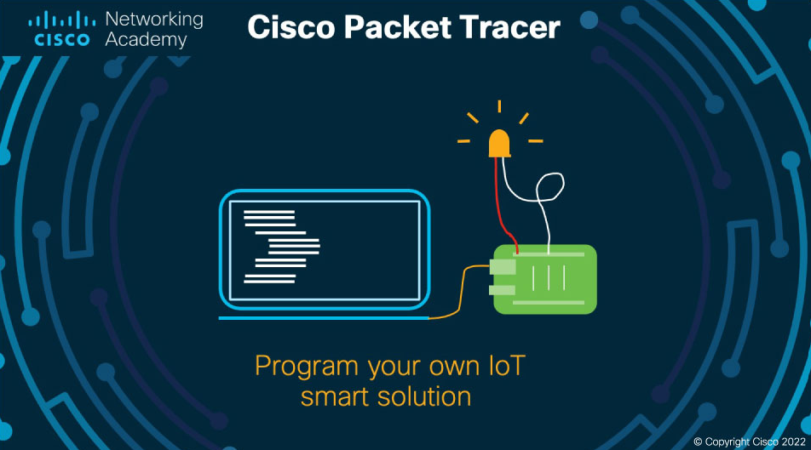

Figure1

Step 2:

*Add one Cisco Router, one Cisco Switches, and other PCs,*  *IP phone on the program’s workspace. Then note the port and slot numbers of the router's GigabitEthernet interfaces in the workspace.*

*Page* ***6****of* ***20***

*Project on sons, summer 22*

*Double-click on the router to open the IOS Command Interface.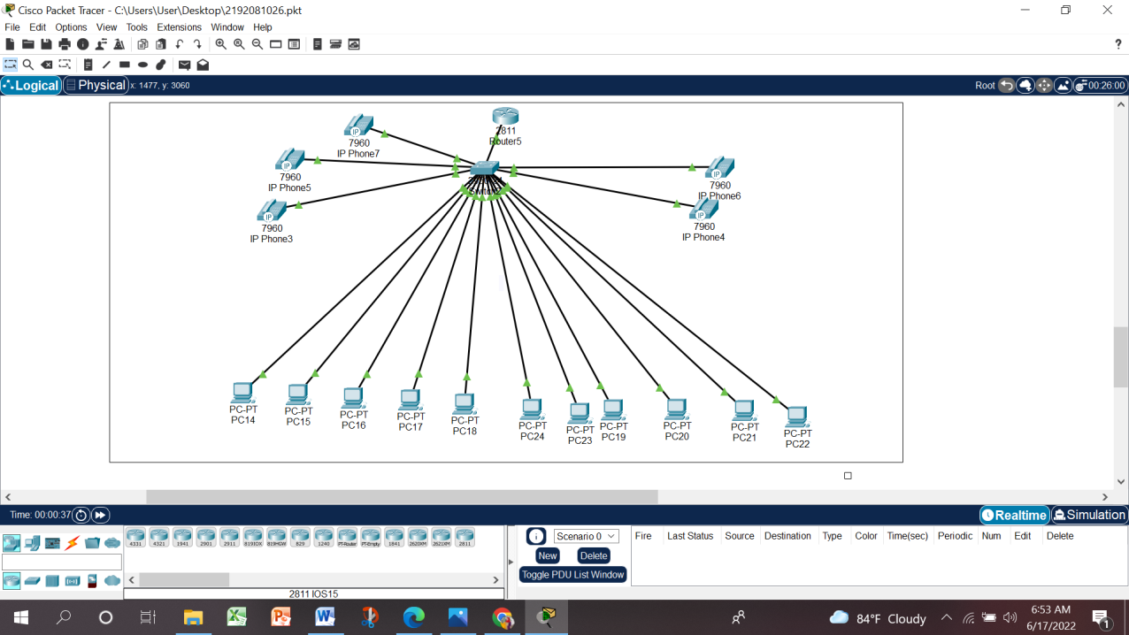*

Figure2

*in the Cisco router CLI window assign an IP address to the GigabitEthernet0/0 interface and execute the no shutdown command to activate the interface.*

*Nusrat jahan bithi, 2192081026 48A Day, Tonima akter, 2191081017 47A*

*Israt jahan sathi, 2192081027 48A Day,Amit hasan, 2192081017 48A*

*Page* ***8****of* ***20***

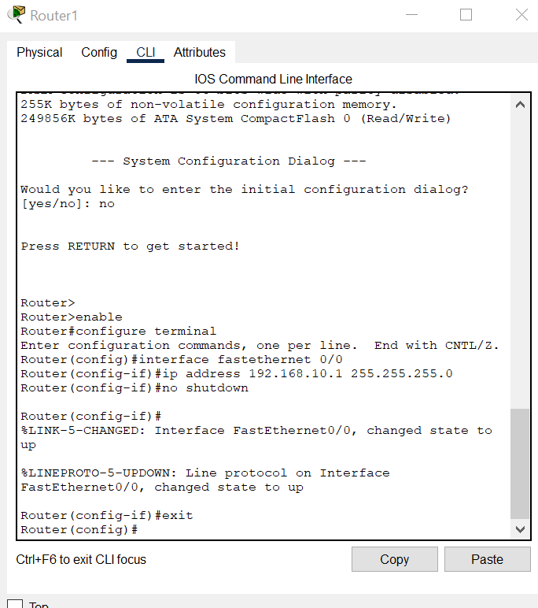

Figure3

*After configuring the GigabitEthernet0/0 interface, the port will be green. The meaning of this color is; The interface is active and working.*

*Verify your configuration changes via the running-configuration.*

*To verify your configuration changes, exit the interface configuration mode to privileged mode by pressing CTRL + Z and executing the command show run interface FastEthernet 0/0*

*Router(config-if)#^Z*

*%SYS-5-CONFIG_I: Configured from console by console*

*Router#show run interface FastEthernet 0/0*

*Building configuration...*

*Current configuration : 148 bytes*

*!*

*interface FastEthernet0/0*

*ip address 192.168.10.1 255.255.255.0 duplex auto*

*speed auto*

*end*

*Router#*

*Step 3:*

*Now, you need to assign an IP address to the computers that you add to the topology. To do this, click on the PC to which you will assign an IP, and on the Desktop tab, click IP Configuration.*

*Then, you need to address the PC according to the IP block of the network on which the network is. According to the topology above, assign an IP address from block 192.168.1.0/24 as PCO is connected to the network under the router's Gig0/0 interface.*

*Page* ***10****of* ***20***

*Project on sons, summer2022*

***Step 4:***

**2.2 Switch ip configuration**

*In the Cisco switch CLI window*

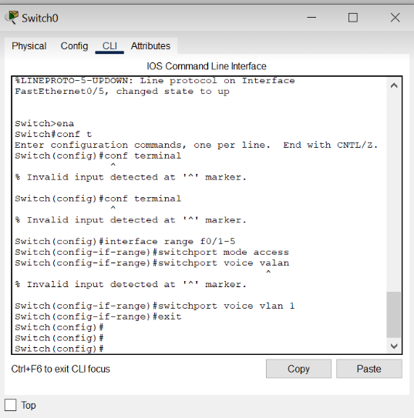

Figure4

2.3.  IP telephony basic configuration:

## *Tasks 1 : Configure interface FastEthernet 0/0 and DHCP server on RouterA (2811 router)*

***Configure the FastEthernet 0/0 interface with 192.168.10.1/24 ip address. Don't forget to enable the interface with the no shutdown command !***

***RouterA>enable***

***RouterA#configure terminal***

***RouterA(config)#interface FastEthernet0/0***

***RouterA(config-if)#ip address 192.168.10.1 255.255.255.0***

***RouterA(config-if)#no shutdown***

***The DHCP server is needed to provide each IP phone connected to the network with an IP adress and the TFTP server location.***

***RouterA(config)#ip dhcp pool VOICE #Create DHCP pool named VOICE***

***RouterA(dhcp-config)#network 192.168.10.0 255.255.255.0 #DHCP network network 192.168.10 with /24 mask#***

***RouterA(dhcp-config)#default-router 192.168.10.1 #The default router IP address#***

***RouterA(dhcp-config)#option 150 ip 192.168.10.1 #Mandatory for voip configuration.***

***After configuring the ISR router, wait a moment  and check that ‘IP Phone 1’ has received an IP address by placing your cursor over the phone until a configuration summary appears.***

## *Tasks 2 : Configure the Call Manager Express telephony service on RouterA*

*You must now configure the Call Manager Express telephony service on RouterA  to enable voip on your network.*

*RouterA(config)#telephony-service #Configuring the router for telephony services#*

*RouterA(config-telephony)#max-dn 5 #Define the maximum number of directory numbers#*

*RouterA(config-telephony)#max-ephones 5 #Define the maximum number of phones#*

*RouterA(config-telephony)#ip source-address 192.168.10.1 port 2000 #IP Address source#*

*RouterA(config-telephony)#auto assign 4 to 6 #Automatically assigning ext numbers to buttons#*

*RouterA(config-telephony)#auto assign 1 to 5 #Automatically assigning ext numbers to buttons#*

## *Task 3 : Configure a voice vlan on SwitchA*

*Apply the following configuration on SwitchA interfaces. This configuration will separate voice and data traffic in different vlans on SwitchA. data packets will be carried on the access vlan.*

*SwitchA(config)#interface range fa0/1 – 5 #Configure interface range#*

*SwitchA(config-if-range)#switchport mode access*

*SwitchA(config-if-range)#switchport voice vlan 1 #Define the VLAN on which voice packets will be handled#*

## *Task 4 : Configure the phone directory for IP Phone 1*

*Although ‘IP Phone 1’ is already connected to SwitchA, it needs additionnal configuration before beeing able to communicate. You need to configure RouterA CME to assign a phone number to this IP phone.*

*RouterA(config)#ephone-dn 1 #Defining the first directory entry#*

*RouterA(config-ephone-dn)#number 01772199294*

*#Assign the phone number to this entry#*

## *Task 4: Verify the configuration*

*Ensure that the IP Phone receives an IP Address and a the phone number 01772199294 from RouterA*

*Page* ***12****of* ***20***

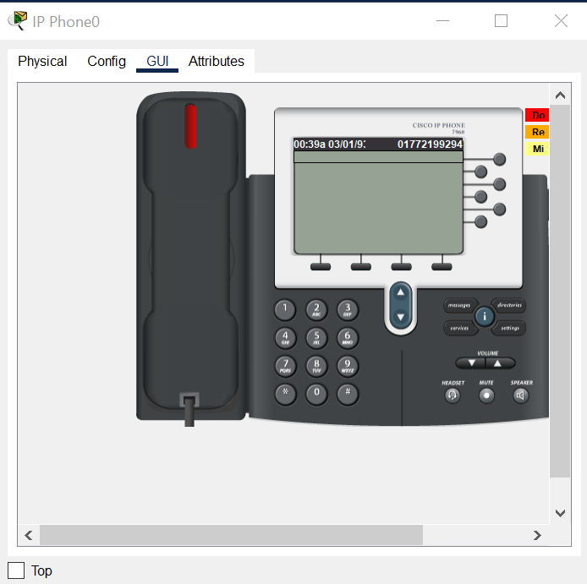

Figure5

## *Task 5 : Configure the phone directory for IP Phone 2*

*Connect IP Phone 2 to SwitchA and power the phone ON using the power adapter (Physical tab).*

*RouterA(config)#ephone-dn 2 #Defining the first directory entry#*

*RouterA(config-ephone-dn)#number 01917100805 #Assign the phone number to this entry#*

*Nusrat jahan bithi, 2192081026 48A Day, Tonima akter, 2191081017 47A,*

*Israt jahan sathi, 2192081027 48A Day,Amit hasan, 2192081017 48A Day*

*Page* ***13****of* ***20***

3 Office Automation Using IoT: *Project on sons, summer2022*

**Project features:**

***3.*** ***RFID Based Door Lock:*** *Door can be unlocked only by using valid RFID card. If anyone wants to enter in the office, he or she has to show RFID. If the RFID is valid, the door will be opened, otherwise not.*

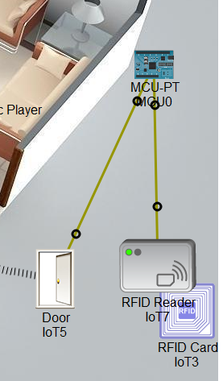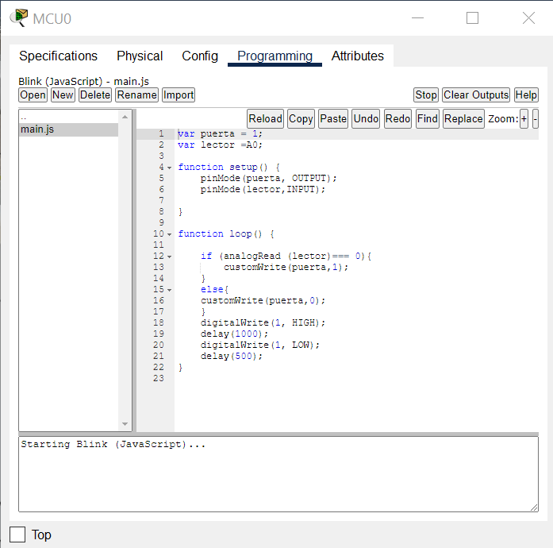

Figure6

***3.1.******MCU****:Home Gateway and microcontroller (MCU) were employed. Devices were registered using home gateway and MCU was used to link sensors to device. Even though programming language support was provided by the cisco packet tracer, the researcher used Java Script and Python for implementation*

Using IoT:

*The cisco packet tracer interface provides inbuilt devices to be added in the network. The first step is to select home gateway device from the network devices. To authenticate and validate the wireless connection, we also can configure home gateway with WEP/WPA-PSK /WPA2 protocols. The second step in simulating a smart office is to connect devices to the home gateway. In this work, 8wireless devices were coupled with the home gateway. The devices configured included fan, webcam, door, light,music player,homespeaker air condition, alam ,window and motion detector.*

*Page* ***14****of* ***20***

*Project on sons, summer2022*

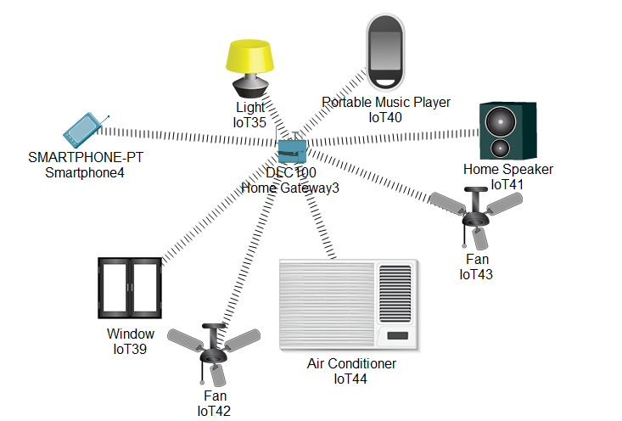

Figure7

*gateway and connected to network wireless. The default gateway is 192.168.25.1.. There is another option called advanced at the bottom which gives additional menus. Here in I/O config tab, the network adapter setting has to be set to PT-IOT-NW-1W.*

***3.2 Smart Window, based on light and rain:*** *Smart Window which will be opened automatically when it’s morning time and there is no rain using rain sensor, photo sensor. If it’s night the window will be closed to avoid the mosquitoes even if there is rain.*

***3.3Solar Power battery charging:*** *Basing on solar power, fan and light will be running automatically. But, if the battery power finishes, they won’t be running. The battery only charges itself when there is sufficient light.*

* 1. ***Anti-theft protection:*** *To provide anti-theft protection trip sensor is being used, if anyone breaks window and enters trip sensor will give siren as alert.*
  2. ***Auto fan & coffee maker:*** *When anyone enters the canteen, fan and coffee maker turns on itself detecting the motion.*
  3. ***Music player:*** *Music can be played using music player via Bluetooth on a portable speaker. Entertainment purpose.*

*3.17* ***Smart street lamp:*** *Turns on when it’s night using photo sensor. Energy saving.*

*3.8* ***Measuring temperature****is one of the most common technique used because it is important for many operations and tasks to be performed like in any industries where heaters are used, heat up to a certain temperature is required. When it comes to sensing temperature, a temperature sensor is used that is installed at a place whose temperature is to be sensed. The temperature of that place can be****monitored through internet using internet of things****.*

*Project on sons, summer2022*

*Monitoring is employed in various applications,including temperature, pressure, flow rate, capacity, acceleration, and so on. According to the quantities, distribution and detected frequency of the monitored objects, there are different monitoring methods to acquire the measurements. Several problems usually occur during the monitoring process of the temperature in a room. For example, a server room must be kept between 15 to 20 degree Celsius to monitor a temperature in or else the server might crash and can cause a loss of hundreds thousands. Management has to choose either to place a person to monitor the temperature, or to save on human capital by developing a system that can monitor the temperature from other places at any given time.*

*In order to solve the problem, the web-based temperature monitoring system that can be access anywhere and anytime through the Internet is build. With this system a user can remotely monitor the room temperature from anywhere which could save the human expenses.****IoT******WebBased Temperature Monitoring****is one type of temperature recorder that monitors a temperature in a room and stores the data into a database and display the current temperature on the website through a web server. The system will continuously monitor the temperature condition of the room and the data can be monitored at anytime and anywhere from the Internet. The temperature monitoring is widely used in various processes like in automotive industries, air conditioning, power plant and other industries that need the data to be saved and analyzed. The main purpose of this system model is to make it easy for the user to view the current temperature.*

***3.1.8. webcam.:*** *IP Cameras are pretty simple things, whether they are Cisco branded ones, or other manufacturers.  They will generally output a video stream over RTSP to something that listens to them.   I'd recommend that you start by reading some of the installation and deployment guides for the current supported Connected Safety Products*

*Page* ***15****of* ***20***

*The next step is to add rules and conditions for the smart objects to give notifications or alarm. In order to do this, from smartphone select the desktop tab and click IoT monitor.*

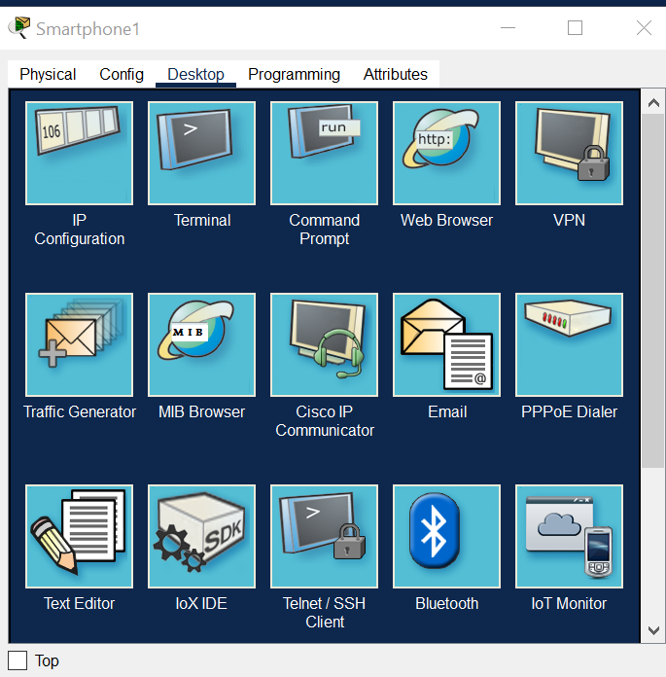

Figure8

*RESULTS Once you finish all the main procedure of designing a smart home environment that is – Add home gateway to the workspace, Add IoT devices to the home gateway in workspace and finally add the end user device such as smartphone, tab, laptop, etc. When the smartphone in the workspace is clicked, IoT server can be selected to verify the connections that have been established.*

*Nusrat jahan bithi, 2192081026 48A Day, Tonima akter, 2191081017 47A,*

*Israt jahan sathi, 2192081027 48A Day,Amit hasan, 2192081017 48A Day*

*Page* ***16****of* ***20***

*Project on sons, summer2022*

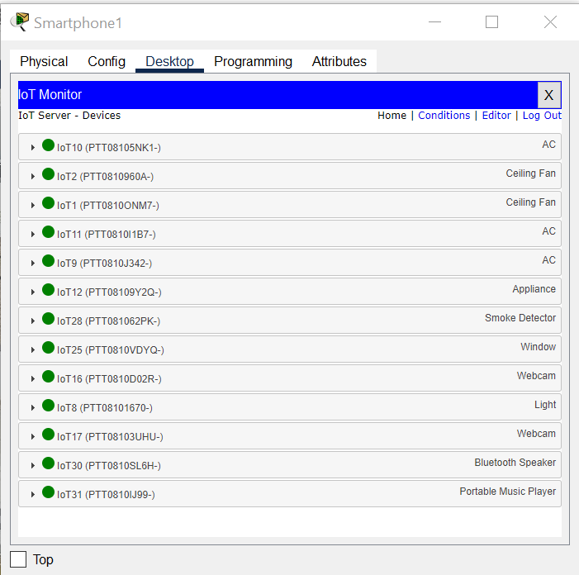

Figure9

*3.6* ***Fire alarm & smoke alarm:*** *If anything catches fire, the fire detector will give siren to alert everyone. If ridiculous amount of smoke is generated by vehicle, smoke detector will siren alert. Even though programming language support was provided by the cisco packet tracer, the researcher used Java Script and Python for implementation*

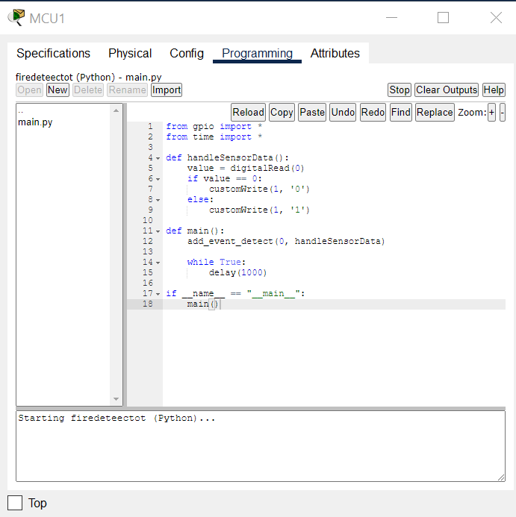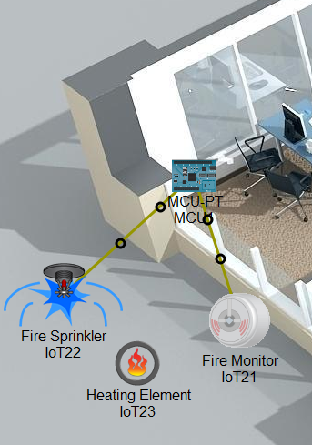

Figure10

*Page* ***17****of* ***20***

*Project on sons, summer2022*

the start and finish smart office environment summary of a project.

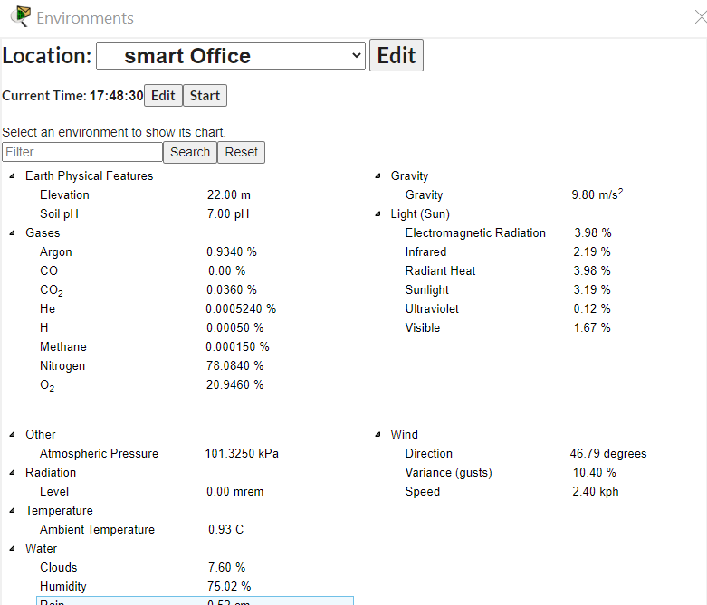

Figure11

*Page* ***18****of* ***20***

*Project on sons, summer2022*

***5.*REFERENCES**

*Corporate Social Responsibility. (2018). Retrieved from* [*https://www.cisco.com/c/en/us/about/csr.html*](https://www.cisco.com/c/en/us/about/csr.html)

*[2] packettracernetwork. (2018, January). (What's new in Cisco Packet Tracer 7.0) Retrieved from packettracernetwork: http://www.packettracernetwork.com/features/packettracer-7- new-features.html*

*[3] A, E., & K. A, H. (n.d.). Design and Implementation of a WiFi Based Home Automation System,. pages 2177-2180.*

*[4] Abdi, A. (2018). Designing Smart Campus Using Internet of Things. International Journal of Computer Science Trends and Technology (IJCST), V 6 I 3 PP 109-116.*

*[5] Aggarwal, R., & Lal Das, M. (2012). RFID Security in the Context of Internet of Things. page 51-56. Kerala: First International Conference on Security of Internet of Things. [6] al, M. c. (n.d.). Designing Smart Campus Using Internet of Things. 6(3).*

*[7] Alexandria, A. (2014). Enabling communication between wireless sensor networks and the internet of things-ACOAP communication stacks. International journal of Science and Engineering, 6-7 Vol.5. [8] AlFarsi, G., & ALSinani, M. (2017). Developing a Mobile Notification System for AlBuraimi University College Students. International Journal of Information Technology and Language Studies(IJITLS), 1(1).*

*[8] ALFarsi, G., Jabbar, J., & ALSinani, M. (2018). Implementing a Mobile Application News Tool for Disseminating Messages and Events of AlBuraimi University College. International Journal of Interactive Mobile Technologies (iJIM),*

*[9] Mumtaz, S., Alsohaily, A., Pang, Z., Rayes, A., Tsang, K. F., & Rodriguez, J. (2017). Massive Internet of Things for industrial applications: Addressing wireless IIoT connectivity challenges and ecosystem fragmentation. IEEE Industrial Electronics Magazine, 11(1), 28-33.*

*Project on sons, summer2022*

**6 .SHORT BIOGRAPHY**

**Group member one:**NUSRAT JAHAN BITHI 2192081026 48(A/DAY)

Mobile: +8801772199294

Email:2192081026@uttarauniversity.edu.bd.

**Group member two:**TONIMA AKTER 2191081017 47(A/DAY)

Mobile:+8801319398919

Email:2191081017@uttarauniversity.edu.bd.

**Group member three:**ISRAT JAHAN SATHI 2192081027 48(A/DAY)

Mobile: +8801917100805

Email:2192081027@uttarauniversity.edu.bd.

**Group member Four:**AMIT HASAN 2192081017 48(A/DAY)

Mobile: 01788259904

Email: 2192081017@uttarauniversity.edu.bd.

*Page* ***20****of* ***20***

***End***